



This project focuses on applying Natural Language Processing (NLP) techniques to analyse user-generated movie reviews from the IMDB dataset. The main goal is to build a system that can automatically classify reviews as positive or negative.
With the rapid growth of OTT platforms, thousands of reviews are generated daily. Manually analysing them is difficult and time-consuming. This project uses machine learning and text processing techniques to automate sentiment detection and extract meaningful insights from textual data.
The project covers:
Text preprocessing
Feature extraction (Bow, TF-IDF)
Model building (Naive Bayes, Decision Tree, etc.)
Word embeddings and visualization

PROBLEM STATEMENT
- Large volumes of movie reviews are generated daily on IMDB, making manual analysis difficult and time-consuming.
- Reviews are unstructured text data, which makes it challenging to extract meaningful insights using traditional methods.
- There is a need to automatically classify reviews into positive and negative sentiments for better understanding of audience opinions.
- Identifying negative reviews early is important to detect poorly performing movies and improve content quality.
- Manual sentiment analysis can lead to errors, inconsistency, and delays in decision-making.
- Businesses require a scalable solution to process and analyse large datasets efficiently.
- There is a need to improve recommendation systems by understanding user preferences through sentiment analysis.
- Traditional keyword-based methods are not sufficient to capture the context and meaning of text data.
- An automated NLP-based system is required to accurately analyse sentiment and support data-driven decisions.

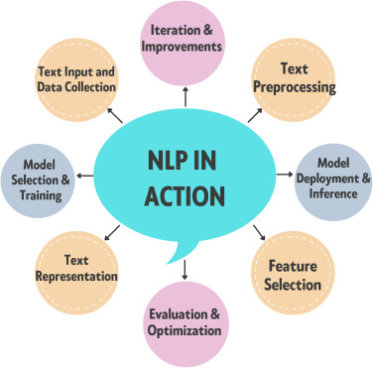

DATASET OVERVIEW

The dataset used in this project is the IMDB Movie Reviews Dataset, which is widely used for sentiment analysis tasks in Natural Language Processing (NLP).
Source of Dataset
https://1drv.ms/x/c/a48c01fec5c3c6a6/IQBLN2O1NBKOSLTtDqbdJI98AbxbgPlzL8JKzt5P7AJZ038?e=lKJUxv
It is a publicly available dataset for NLP and machine learning practice
Dataset Description
The dataset contains 50,000 movie reviews collected from IMDB users
Each review is labelled based on the sentiment expressed by the user
Dataset Structure
The dataset consists of the following columns:
review
Text data containing the user's movie review
sentiment
Target variable indicating sentiment (positive / negative)

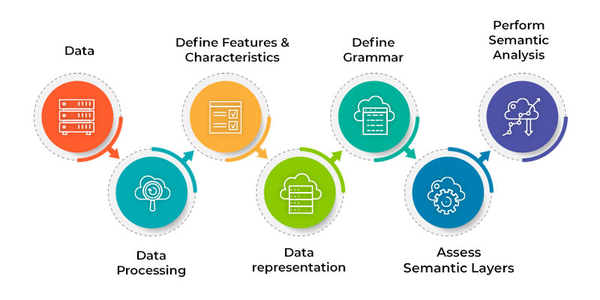
DATA UNDERSTANDING AND EXPLORATION

Data understanding and exploration is the first step in any data science or NLP project. It involves analysing the dataset to understand its structure, distribution, and quality before applying preprocessing and modelling techniques.
Loading the Dataset
The IMDB movie reviews dataset is loaded into a pandas Data Frame for analysis. This allows easy manipulation and exploration of the data.
After loading, the dataset is stored in tabular form with rows and columns.
Displaying Initial Data
To understand the dataset structure:
The first 5 rows (head) are displayed to observe sample data
The last 5 rows (tail) are displayed to confirm dataset consistency
This helps verify:
Column names
Data format
Sentiment labels
Dataset Size
The total number of reviews in the dataset is analysed.
Total Records: 50,000
This indicates that the dataset is large enough for training machine learning models effectively.
Understanding Columns
The dataset contains two main columns:
Review Column
- Contains user-written movie reviews
- Unstructured text data
- Varies in length and style
Sentiment Column
- Target variable
- Contains two classes:
- Positive
- Negative
Sentiment Distribution
The number of reviews in each sentiment category is analysed.
- Positive Reviews: 25,000
- Negative Reviews: 25,000
This shows that the dataset is balanced.
Why Balanced Data is Important:
- Prevents bias toward one class
- Improves model performance
- Ensures fair predictions
Checking for Missing Values
The dataset is checked for null or missing values in each column. Observation:
No significant missing values found
Importance:
- Missing values can affect model accuracy
- Clean data ensures better results
Data Type Analysis
- Review column → Text (string/object type)
- Sentiment column → Categorical
- Sentiment needs to be converted into numerical form before model training.

TEXT PREPROCESSING
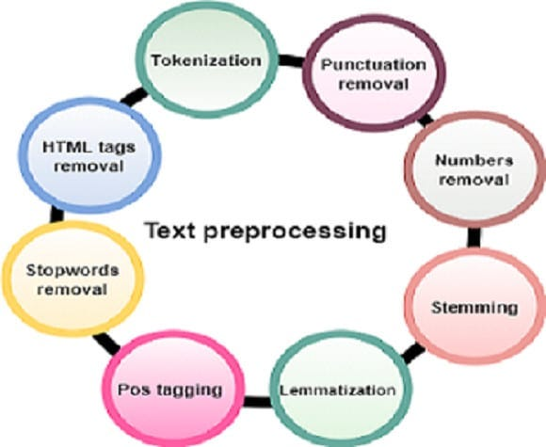
Text preprocessing is a crucial step in Natural Language Processing (NLP) that transforms raw and unstructured text data into a clean and structured format suitable for analysis and model building. Real-world text data often contains noise such as HTML tags, punctuation, numbers, and irrelevant words, which can negatively impact model performance.
Steps in Detail:
Lowercase Conversion
All text is converted into lowercase to ensure uniformity. For example, “Movie” and “movie” should be treated as the same word.
Removal of HTML Tags
IMDB reviews often contain HTML elements like <br>, which do not contribute to sentiment. These are removed using regular expressions.
Removal of Special Characters and Numbers
Punctuation marks, symbols, and numbers are removed since they usually do not add meaningful information for sentiment classification.
Removal of Extra Whitespaces
Unnecessary spaces between words are removed to maintain consistency.
Tokenization
Text is broken down into individual words (tokens).
Example:
"This movie is good" → ["this", "movie", "is", "good"]
Stop word Removal
Common words such as the, is, in, and are removed as they do not carry significant meaning.
Lemmatization
Words are converted to their base or root form.
Example: running → run, better → good

FEATURE ENGINEERING
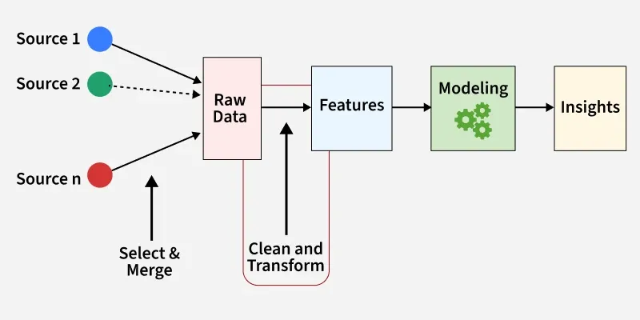
Feature engineering is the process of converting textual data into numerical format so that machine learning models can process it.
Bag of Words (Bow)
Bag of Words is a simple technique where:
- Each unique word becomes a feature
- The value represents word frequency in a document
Characteristics:
- Ignores grammar and word order
- Creates sparse matrix
- Easy to implement
Limitation:
- Does not capture context or meaning
TF-IDF (Term Frequency – Inverse Document Frequency)
TF-IDF improves Bow by assigning weights to words based on importance.
Formula Concept:
- Term Frequency (TF) → How often a word appears
- Inverse Document Frequency (IDF) → Penalizes common words

TRAIN TEST SPLIT
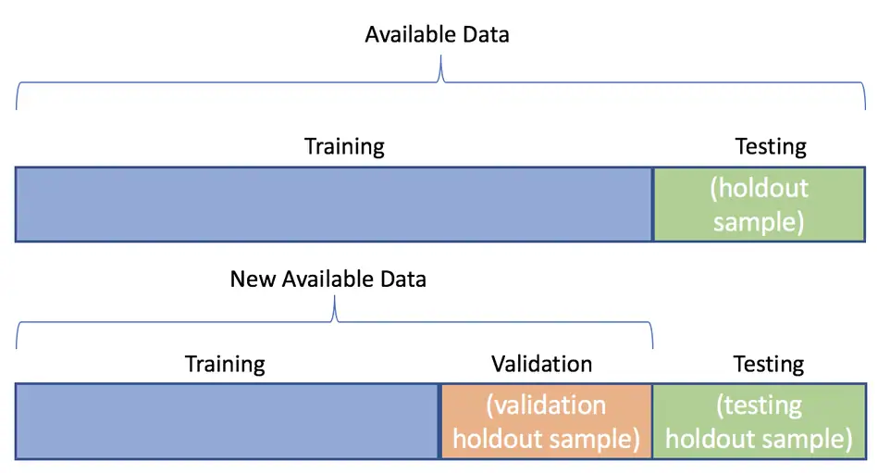
To evaluate model performance, the dataset is split into two parts:
Training Set (75%)
Used to train the model and learn patterns
Testing Set (25%)
Used to evaluate how well the model performs on unseen data
Importance:
Prevents overfitting
Ensures model generalization

MODEL BUILDING----CLASSICAL NLP MODELS
Naive Bayes Classifier
Naive Bayes is a probabilistic algorithm based on Bayes Theorem. It assumes that features (words) are independent of each other.
it works well in NLP:
- Text data has high dimensionality
- Works efficiently with sparse data
Advantages:
- Fast training and prediction
- Performs well even with small data

EVALUATION METRICS
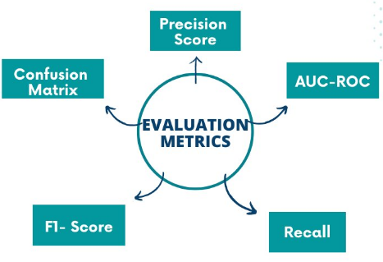
Accuracy
Percentage of correctly predicted reviews.
confusion Matrix
A table showing:
- True Positive (TP)
- True Negative (TN)
- False Positive (FP)
- False Negative (FN)
Precision
Out of predicted positives, how many are correct.
Recall
Out of actual positives, how many are correctly identified.
F1-score
Harmonic mean of precision and recall.
Additional Models (Detailed)
Decision Tree
- Splits data based on conditions
- Easy to interpret
Limitation:
Can overfit on training data
K-Nearest Neighbours (KNN)
- Classifies based on nearest neighbours
- Uses distance metrics
Limitation:
Slow for large datasets
Random Forest
- Ensemble of multiple decision trees
- Uses voting mechanism
Model Comparison
Models are compared using:
Precision
Recall
F1-score
The best model is f1score

Overall performance comparison table
MODEL | PRECISION | RECALL | F1-SCORE
Naïve bayes | 0.85 | 0.84 | 0.84
Decision tree | 0.78 | 0.77 | 0.77
KNN | 0.80 | 0.79 | 0.79
Random forest | 0.88 | 0.87 | 0.87

VISUALIZATION AND INTERPRETATION
Visualization plays a crucial role in understanding patterns, trends, and relationships in data. In this project, various visualization techniques are used to interpret the sentiment distribution and textual patterns in IMDB reviews.
Sentiment Distribution Visualization
A bar chart is used to display the number of positive and negative reviews.
Interpretation:
- The dataset contains equal numbers of positive and negative reviews
- This confirms that the dataset is balanced
- A balanced dataset ensures that the model does not become biased toward any one class
Word Cloud Visualization
Word clouds are generated separately for positive and negative reviews to highlight the most frequent words.
Positive Word Cloud
Interpretation:
- Frequently occurring words include good, amazing, excellent, love, best
- These words indicate strong positive sentiment and satisfaction
Reviews focus on:
- Quality of movie
- Acting performance
- Storyline
- Larger words in the cloud represent higher frequency, showing what users appreciate most.
Negative Word Cloud
Interpretation:
- Common words include bad, worst, boring, waste, poor
- These words indicate negative sentiment and dissatisfaction
- Reviews highlight issues like:
- Poor storyline
- Weak acting
- Lack of engagement
- Negative reviews often contain more specific criticism.
Frequent Words Visualization
A bar chart is used to show the most frequent words in both positive and negative reviews.
Interpretation:
- Positive reviews contain appreciation-based words
- Negative reviews contain criticism-based words
- Some neutral words like movie appear in both categories
Word Embedding Visualization (2D/3D)
Word embeddings are visualized using dimensionality reduction techniques like PCA or t-SNE.
Interpretation:
Words with similar meanings are grouped together
Example:
good, excellent, amazing appear close
bad, worst, boring appear close
Overall Interpretation
- Visualizations provide clear insights into data distribution and sentiment patterns
- Word clouds and frequency charts help understand user opinions
- Confusion matrix and performance charts evaluate model effectiveness
- Word embeddings reveal semantic relationships between words

INSIGHTS
- The dataset is balanced with equal positive and negative reviews, ensuring unbiased model training
- Text data is unstructured, requiring preprocessing for meaningful analysis
- Preprocessing steps like stop word removal and lemmatization significantly improve data quality
- TF-IDF performs better than Bag of Words by capturing word importance
- Naive Bayes works efficiently as a baseline model for text classification
- Random Forest provides higher accuracy and better generalization compared to other models
- Positive reviews contain emotional words (e.g., amazing, excellent)
- Negative reviews contain critical words (e.g., worst, boring)
- Word clouds clearly show sentiment patterns and frequent words
- Word2Vec captures semantic relationships between words effectively
- Visualization techniques help in easy interpretation of results
- Model performance depends heavily on feature engineering and preprocessing quality

RECOMMENDATIONS

- Use advanced deep learning models like LSTM and BERT for better accuracy
- Replace or combine TF-IDF with Word Embeddings (Word2Vec, Glove)
- Implement real-time sentiment analysis for live review data
- Improve preprocessing using:
- Named Entity Recognition (NER)
- Part-of-Speech (POS) tagging
- Build a web or mobile application for real-world usage
- Extend the system to multi-class sentiment analysis (positive, negative, neutral)
- Use larger and diverse datasets to improve model robustness
- Optimize models using hyperparameter tuning
- Apply cross-validation for better model evaluation
- Integrate the system with recommendation engines for personalized suggestions

IMDB business case
Tool use: google collab
LINK: https://github.com/kintaladhanalaxmi2007-ux/NATURAL-LANGUAGE-PROCESSING/blob/main/NLP_SENTIMENT_ANALYSIS.ipynb

CONCLUSION
This project demonstrates how NLP techniques can be used to classify movie reviews into positive and negative sentiments. Text preprocessing and feature engineering improved data quality, while models like Naive Bayes and Random Forest provided good performance. TF-IDF performed better than Bag of Words, and Word2Vec helped capture word meanings. Overall, the project shows that sentiment analysis is effective for understanding user opinions and can be improved further using advanced models.

